**Welcome to the SlamJam**

**RULES:** Practical Shooting Handbook, Latest Edition **COURSE DESIGNER:** Kirt McKenna

|  |  |
| --- | --- |
| **START POSITION:** Standing anywhere in the shooting area, facing downrange.  Handgun is loaded and holstered with wrists below belt.  **PCC START:** Same as handgun with stock on belt and muzzle pointed downrange. | |
| **STAGE PROCEDURE**  On start signal engage targets as they become visible, from within the shooting area. | **SCORING**  **SCORING:** Comstock, 30 rounds, 150 points  **TARGETS:** 13 USPSA, 4 Colt Steel  **SCORED HITS:** 2Best per USPSA, Steel 1 KD = 1A  **START-STOP:** Audible - Last shot  **PENALTIES:** Per current USPSA rulebook |

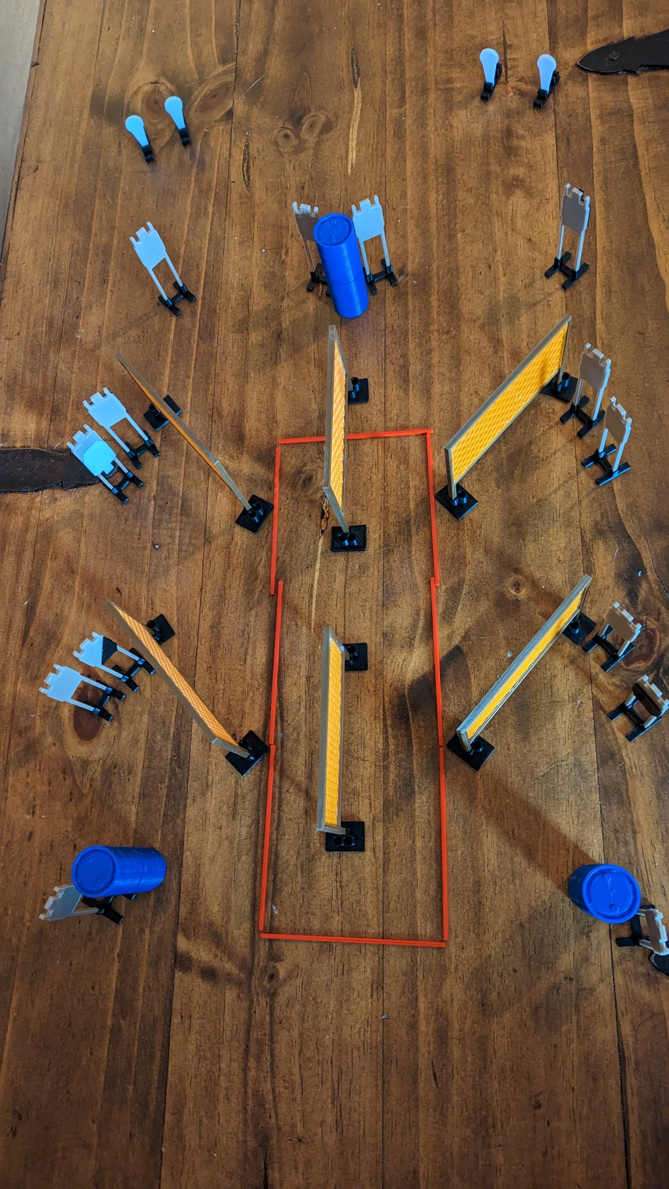

**SHOOTING AREA**

|  |  |  |
| --- | --- | --- |
| **SETUP NOTES**: |  | **RO NOTES**: |